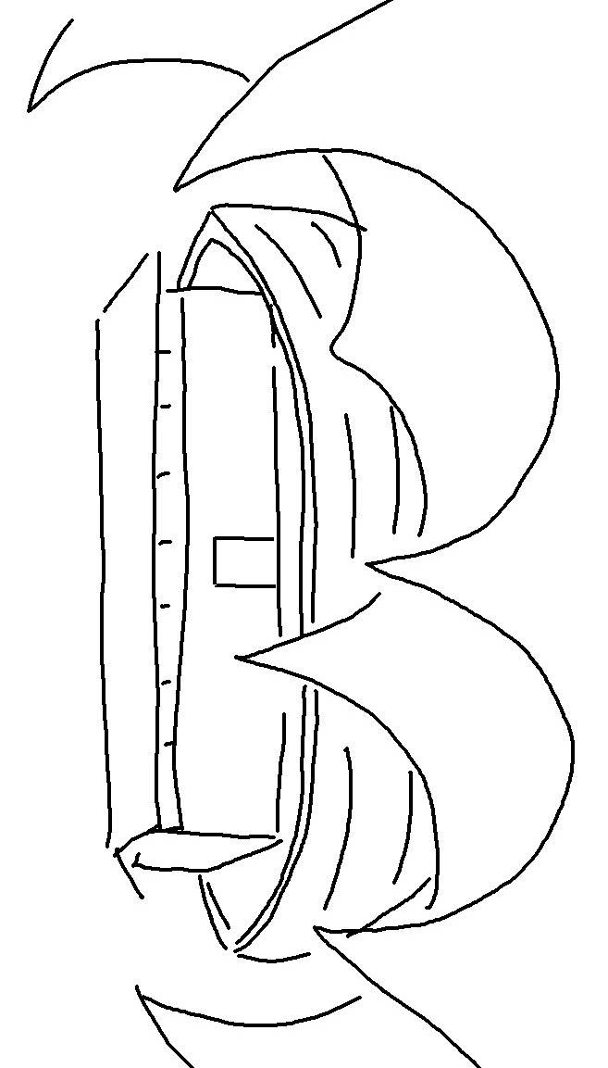
Everyone who calls on the name of the Lord will be saved.Romans 10:13_{NLT}

